Spatial diversity of halite nodule microbiomes

Results:

1. Halite microbiome composition is significantly different between major regions of Salar Grande. Specifically, SG1-Top is very different from SG2-Top. Rock topologies are not significantly different, but the weather is, and humidity differences likely drive the composition differences. The composition as a whole is affected, but also phyla abundances are affected. This means that the composition at this high level are influenced by deterministic environmental differences.



*Comparing weather in SG1 and SG2. SG2 appears to be overall hotter and dryer than SG1. However, the humidity fluctuations in SG2 are less extreme - at night SG2 does not get as humid as SG1, but in the day SG2 remains more humid than SG1.*

*Topography comparison between SG1 and SG2 regions, measured with the relative coverage of the ground with halite nodules at different stages of development. No significant surface coverage was found between SG1 and SG2 (two-tail equal variance t-tests).*

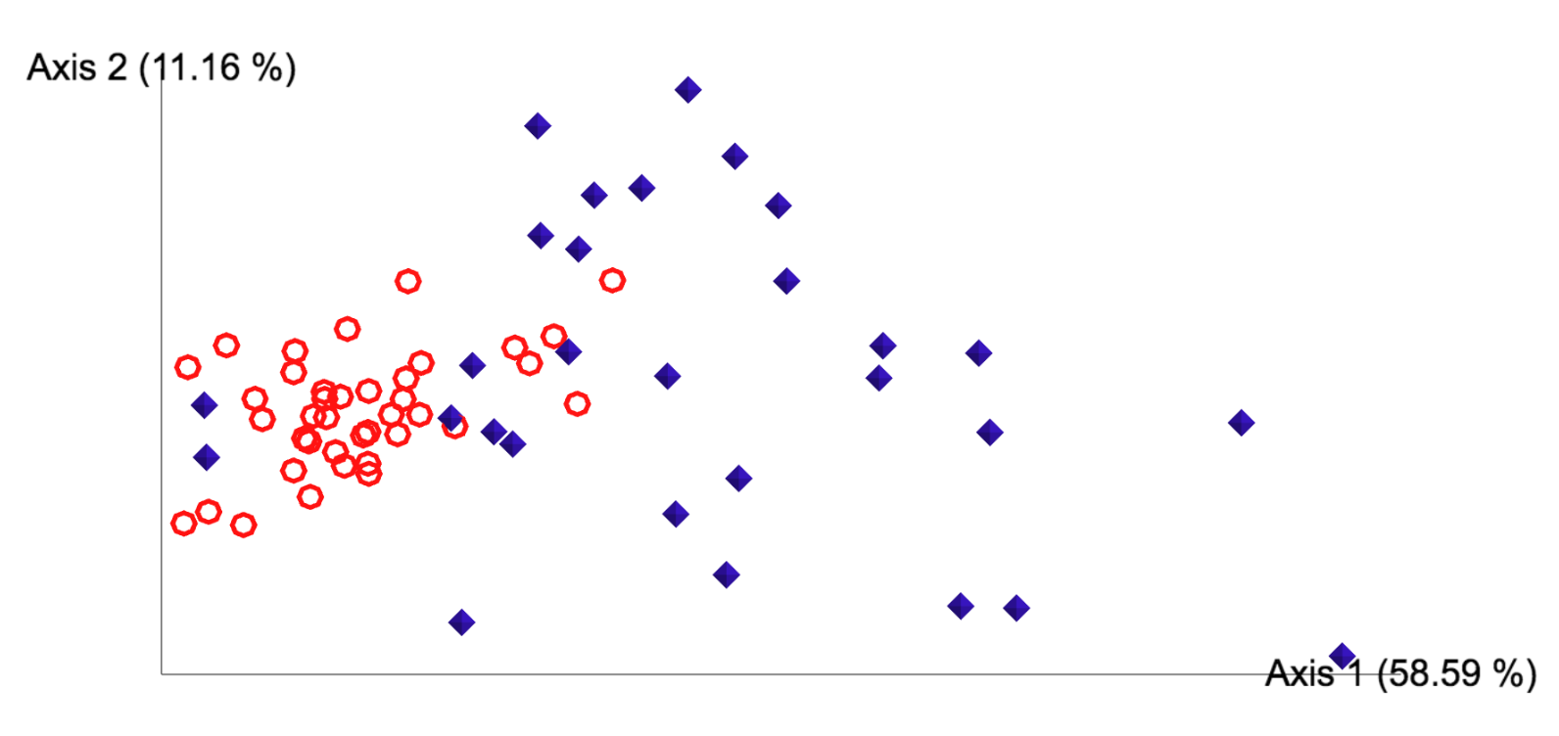

*PCoA of weighted Unifrac dissimilarity matrix of 16S rDNA amplicon sequences from SG1 (red rings) and SG2 (blue diamonds). Difference is significant (PERMANOVA: pval<0.001, test statistic= 28.36).*

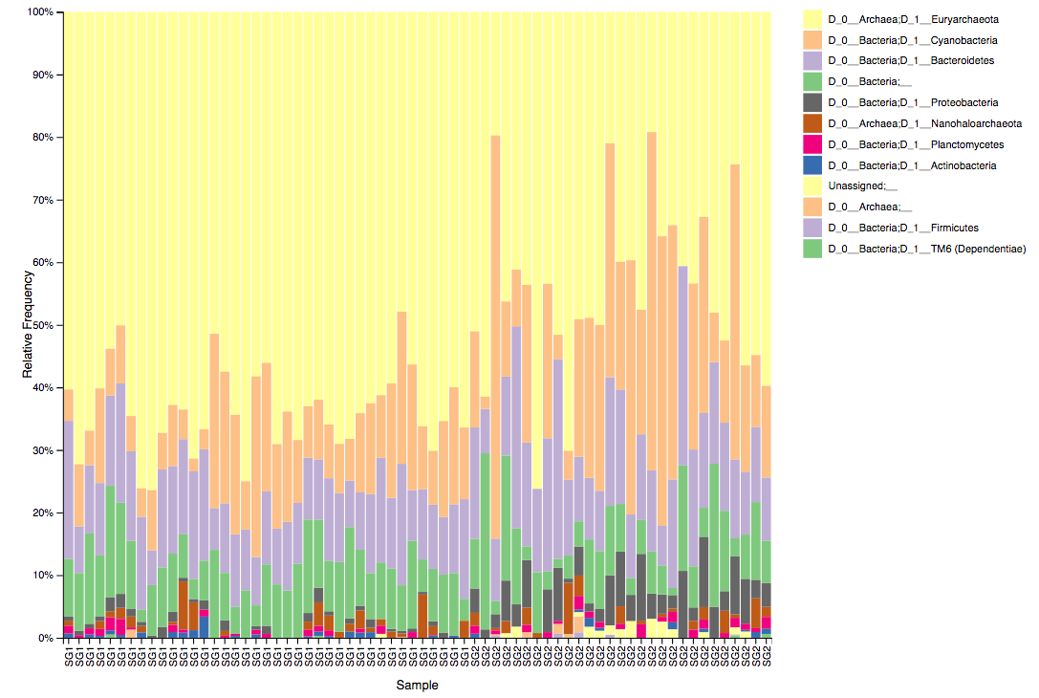

*Relative taxonomy composition of SG1 and SG2 locations at the D3 (class level). Cyanobacteria are significantly more abundant in SG1, while Proteobacteria were more [relative] abundant in SG2 (ANCOM, W=10). At the domain level, Archaea was significantly more [relative] abundant in SG1 (ANCOM, W=2). Interestingly, no significantly differential taxa were detected at the ASV (amplicon sequence variant) level.*

1. Composition of halite nodules at the same location (SG1) is different between the top and bottom of a small hill. The topography of the rocks is drastically different between these locations, which could influence colonization. Also, the humidity and temperature conditions are also different, which we already know affects the composition. The composition correlates nicely with elevation. Again, the differences in composition at this level are deterministic.



*Comparing weather on the bottom and top of the SG1 hill. The bottom (the flat) is consistently hotter and dryer than the top of the hill. Importantly, the top of the hill experience humidity above deliquescence point (75% RH) much more often. These results are confirmed with the HOBO probes positioned 1m above the ground (over 2 days).*

*Topography comparison between the top and bottom of a hill at, measured with the relative coverage of the ground with halite nodules at different stages of development. The top of the hill had a significantly higher nodule coverage, and less flat polygons (two-tail t-tests: pval<0.01).*



*Relative taxonomy composition of halite communities at the top and bottom of the SG1 hill in 2016 at the phylum level. Nanohaloarchaea, Proteobacteria, and Actinobacteria were found to be significantly more abundant at the top of the hill than the bottom (ANCOM W=6,9,8, respectively), and Cyanobacteria was more abundant at the bottom of the hill (ANCOM W=7).*



*PCoA of weighted Unifrac dissimilarity matrix of 16S rDNA amplicon sequences from the top (blue diamonds) and bottom (red squares) of a hill at the SG1 location. Data collected in Feb 2016. Difference is significant (PERMANOVA: pval=* 0.001*, test statistic= 22.5).*

1. Within the individual halites, there are also drastic differences. Each halite is significantly different from the next in phyla abundance, OTU presence/absence. These differences are governed by neutral processes associated with the random colonization of the nodules.

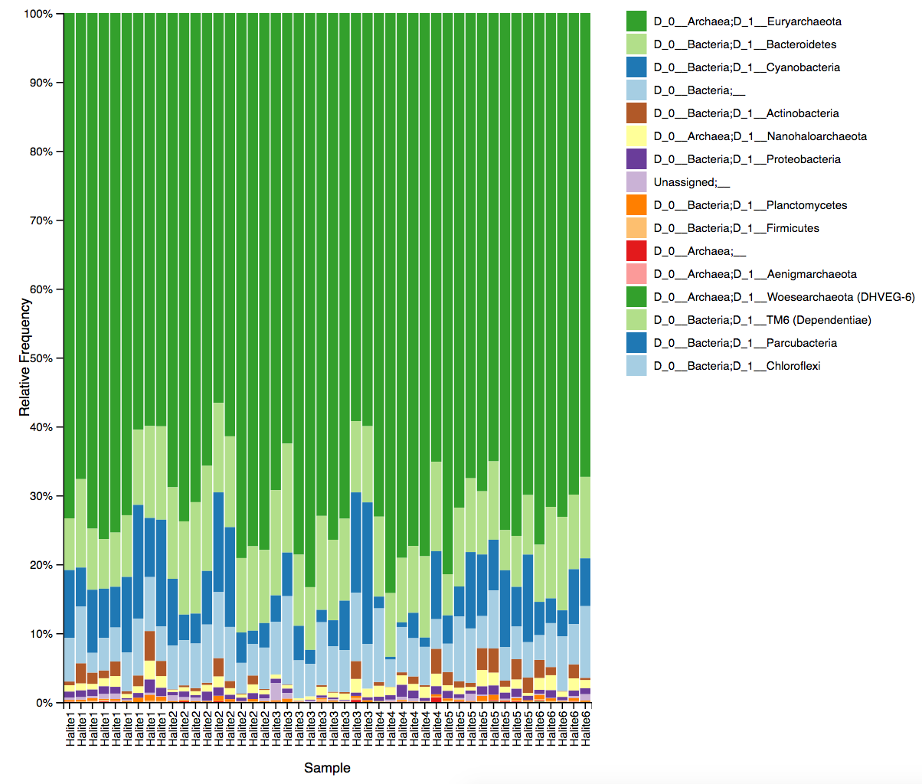

*Relative taxonomy composition of individual halites at the phylum level. Note the relative similarity of intra-halite replicates, and the significant differences between halites (PERMANOVA on Bray Curtis dissimilarity matrox: pval<0.001, test-statistic=* 2.89*). Woesearchaeota, Actinobacteria, Cyanobacteria, Firmicutes, and Proteobacteria were found to be significantly differentially present between nodules (ANCOM W=12, 14, 10, 11, and 11, respectively).*

1. The top-middle-bottom section positioning within any given halite also influences the microbiome composition, but in a more deterministic way. The diversity and OUT presence/absence between the different sections of a single nodule are minor, but certain phyla prefer specific locations. These differences are influenced deterministically by light access (for cyanobacteria), and the humidity gradient across the halite interior.



*Internal condition comparison between the top (5cm below surface from top) and bottom (5cm below surface from bottom) of a halite nodule. The humidity and temperature differences are minor, but the top is a bit warmer and dryer in the day.*

 *Internal condition comparison between the top (5cm below surface from top) and middle (15cm below surface) of a halite nodule. The temperature differences are minor, the humidity remains significantly higher in the middle of the halite, especially during the day. During the night the halite regains the moisture it lost during the day, however the humidity swings in center of the nodule are much smaller than at the surface.*

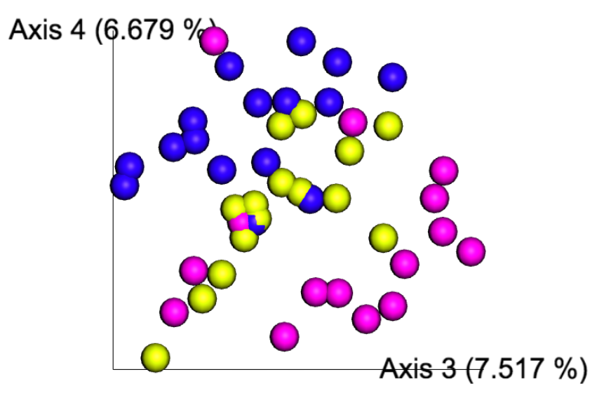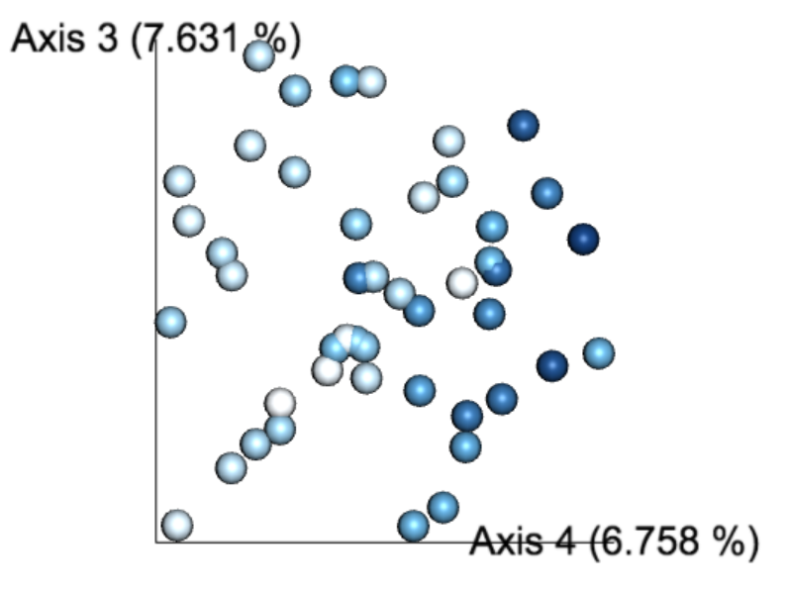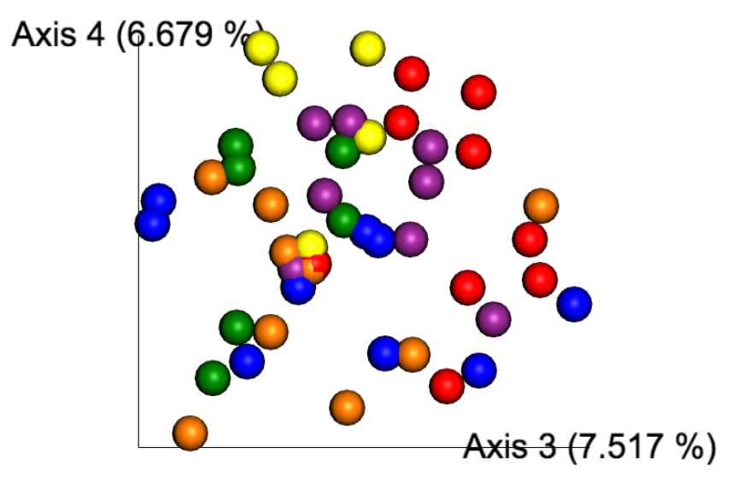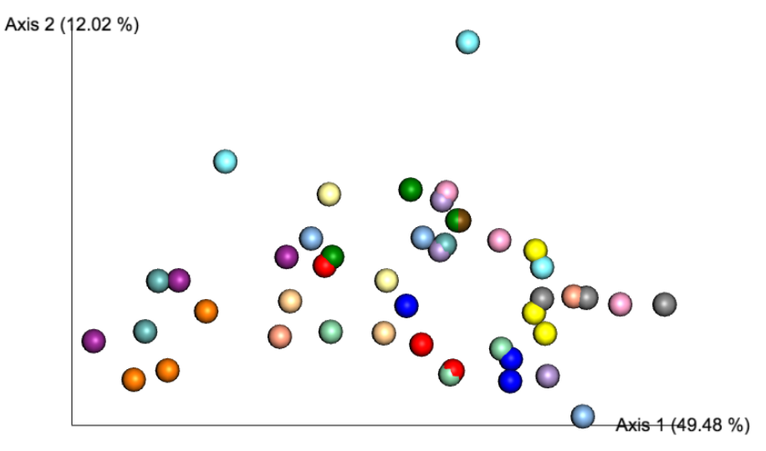

*A: PCoA of Weighted Unifrac dissimilarity matrix of samples collected at different position in the rock, showing composition differences between the top (yellow), middle (blue), and bottom (magenta) of the nodules, revealing a significant signal (PERMANOVA: pval<0.013, test statistic=2.59). B: Same PCoA colored by the distance of sample to the surface (dark is far from surface). C: The same PCoA, but colored based on the halite nodule the sample came from, showing a significant signal (PERMANOVA: pval=0.012, test statistic=* 2.15*). D: The same PCoA but with the second and third principal components, showing significant separation based on the slice that the sample came from (PERMANOVA: pval<0.001, test statistic=* 2.77*)*

*Standardized relative abundances of major phyla in top middle and bottom of halite nodules across all samples. To account for high inter-slice and inter-nodule variation, the abundance of each taxa in each sample was standardized to the average abundance of that taxa in that slice, and multiplied by the average abundance of that taxa in all samples. Astd=μtotal\*A/μslice. All taxa are significantly differentially present between the three sites (one-way ANOVA, pval<0.01). Bars indicate standard error.*

In conclusion, the water availability seems to be the governing factor in halite microbiome composition, at large scales (different sampling sites) and intra-halite scales (position within the nodule). However, the fine-scale composition between adjacent nodules appears to be more random, and is likely driven by neutral processes from the initial colonization of each nodule. Additionally, nodule topology can also have an effect on the composition, as it may be important for light penetration and humidity retention.